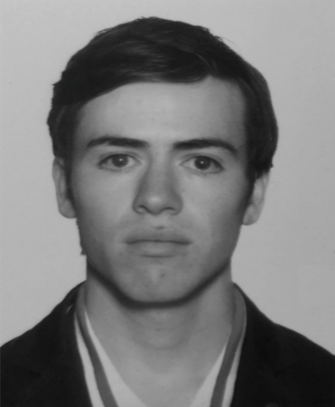

**Industrial and Systems Engineer.**

**Juan Ramón Félix Álvarez Tostado.**

[juan.r.felix13@gmail.com](mailto:juan.r.felix13@gmail.com)

**Home:** (01) 728-287-64-24 o (01)728-287 52-17 **Mobile:** (55) 47-66-91-35.

**Ciudad de México.**

Objective.

Industrial and Systems Engineering, currently studying a Masters in project management. Seeking for a job to leverage acquired academic knowledge and apply my abilities working for a leading company.

Education.

2018 – Current **Master degree in project management . Unitec.** Ciudad de México

2020 – Current **Data Analytics Boot Camp. ITESM Campus Monterrey/Trilogy. (Live online course).** Ciudad de México

2013 – 2018. **Industrial and System Engineering. ITESM Campus Santa Fe** Ciudad deMéxico

07/2017-11/2017. **Logistics and Supply Chain Certification.** Melbourne Australia

University of Victoria.

2009-2012. **Full High School in** Vermont United States, St Johnsbury Academy

Languages:

Fluent:

Spanish 100%

English 90% TOEFL 563

Understanding:

German 20%

Portuguese 40%

**Software**:

Minitab, Matlab, GAMS, Microsoft Excel, Microsoft Project, Microsoft Visual Basic, Microsoft Visual C++, Arena, Analogic, SAP, Solid Works, AutoCAD, AutoCAM, CNC Simulator ,Python, MySQL

## Experience.

Jobs:

Volaris (airline ) CDMX, Mexico

Maintenance aircraft fleet Coordinator 07/2018 – Current date

* Coordinate de checkups in all the international bases and guarantee that in each base

we have trained staff to repair the plane and the parts and materials to perform the maintenance checkups and jobs.

Professional Practices:

Seams (Safety equipment manufacturer) CDMX, Mexico

Consulting project in a PyME 01/2018 - 05/2018

* In this project, the task that was made are the following: make a diagnostic on the process of the most important SKU´s, create a tool to generate codes and enable de ERP ASPEL with modules SAE and PROD ( Administration and Control of Production modules).

Autoliv AMX (Security auto parts provider) Toluca, Mexico Student inter quality engineer                                                                           01/2017 - 05/2017

* Project to improve the process of parts in warranty through streamlining the communication and the parts to be inspected

Chassix (Auto parts supplier)                                                                   CDMX, Mexico

Student Inter in the Quality Department 04/2016

* Project in order to learn how to ensure quality in the automotive industry

Guanajuato state government              Gto , Mexico   
Administrative Assistance in the public center for entrepreneurship 01 / 2015 – 05 / 2015

* Process and service consulting project.

Auto Model Magazine (Personal online blog and Magazine CDMX, Mexico

01 / 2015 – current date

Co-Founder and blogger of the online motoring racing and automobile industry related platform  
<https://www.facebook.com/AutoModelMagazine/insights/?section=navLikes>

<https://www.youtube.com/channel/UCt5sHfVn8aQ41c8vDz5U5mg>

Social service:

Association APAC (Association dedicated to helping people with mobility difficulties) CDMX, Mexico

Administrative assistance                                                                                       06/2017 - 07/2017

* Consulting processes and materials replenishment

FabLab (Stanford global association dedicated to providing technology and engineering courses for elementary and high school students) CDMX, Mexico

Programming tutor 01/2017 - 05/2017

* Teaching of programming courses using basic programming in Scratch and use of microprocessors

Centro Comunitario Santa Fe (Public academic support center for education) CDMX, Mexico

Teacher of ​​mathematics 08 / 2016 -11/ 2016

## Hobby’s.

Triathlon regularly

Fishing

Reading

Traveling (Have been to more than 25 countries and lived in 4)